Practical No. 6

Java Web Services

Q.1] Create Web Service in Java and consume using Java.

Web Service Producer

Steps:

1. Create project > Java Web > Web Application
2. All default settings
3. Glassfish server
4. Project name > right click > web service file
5. Give name and package name and all other default
6. Right click > Web Services file > “Add Operation”
7. Give name and add parameters
8. Project name > Deploy
9. Web Services file > right click > “Test Web Service”

Code:

/*

* To change this license header, choose License Headers in Project Properties.

* To change this template file, choose Tools | Templates

* and open the template in the editor.

*/

package mainPackage;

import javax.jws.WebService;

import javax.jws.WebMethod;

import javax.jws.WebParam;

/**

*

* @author student

*/

@WebService(serviceName = "MainService")

public class MainService {

/**

* This is a sample web service operation

*/

@WebMethod(operationName = "hello")

public String hello(@WebParam(name = "name") String txt) {

return "Hello " + txt + " !";

}

/**

* Web service operation

*/

@WebMethod(operationName = "toGrade")

public String toGrade(@WebParam(name = "percent") double percent) {

//TODO write your implementation code here:

if (percent > 90) {

return "O";

} else if (percent > 80 & percent <= 90) {

return "A";

} else if (70 < percent & percent <= 80) {

return "B";

} else if (60 < percent & percent <= 70) {

return "C";

} else if (50 < percent & percent <= 60) {

return "D";

}else{

return "F";

}

}

}

Output:

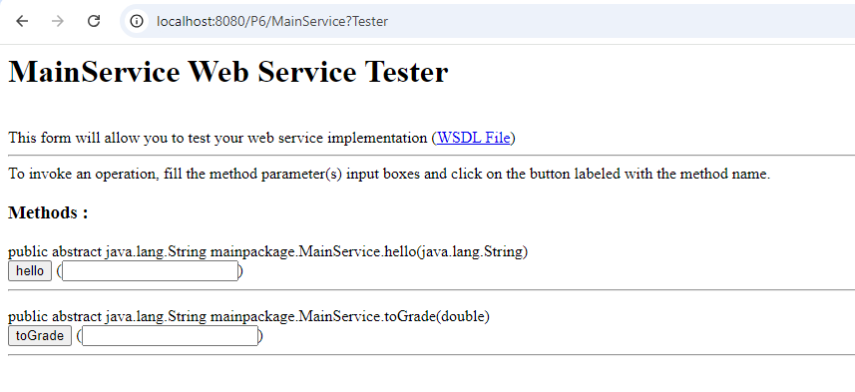

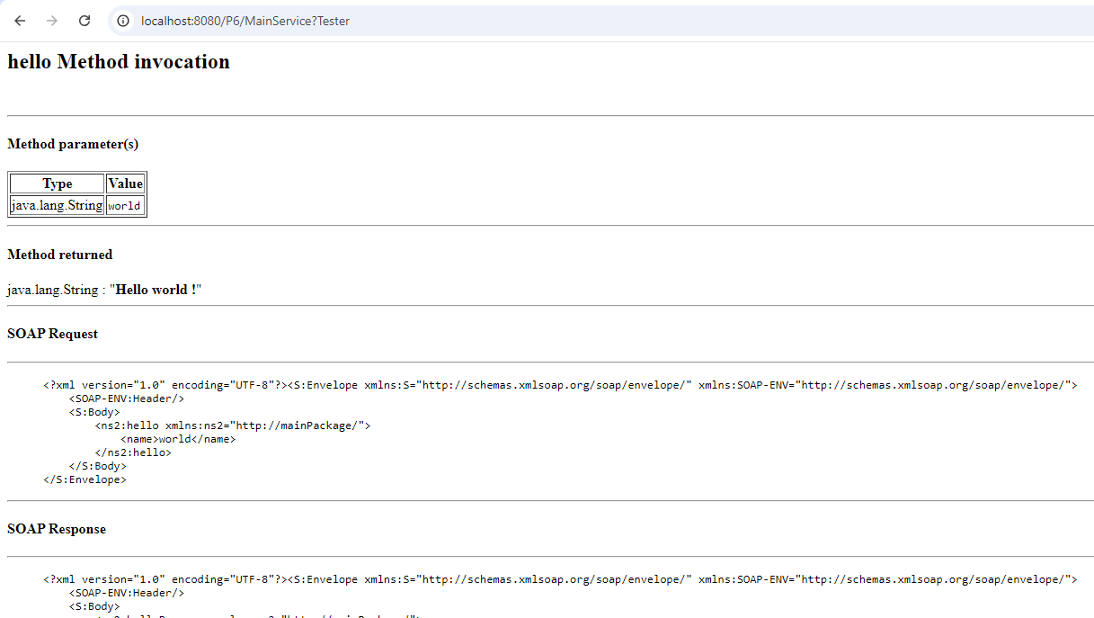

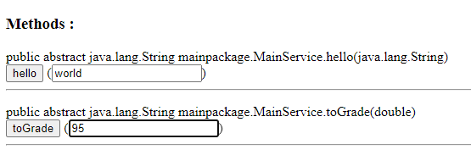

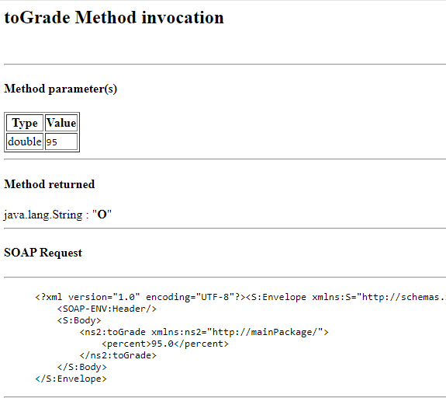

Web Service Consumer

Steps:

1. Right click > Other > Add “Web Service Client” file
2. Get WSDL URL by clicking blue link

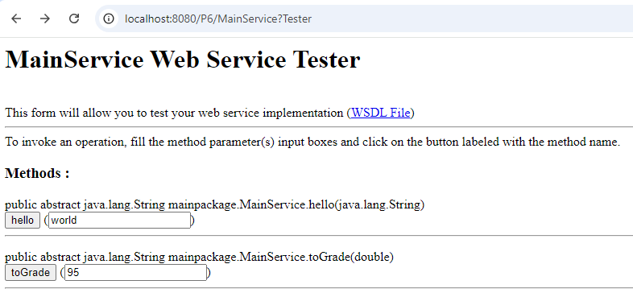

1. Set WSDL URL
2. Select package name
3. Click finish
4. **IMPORTANT:** First the create the service class and then create port class and get the port using serviceClass.getPort() and use the port class to call the methods.

Code:

package mainPackage;

import newpackage.*;

/**

*

* @author student

*/

public class NewClass {

public static void main(String[] args){

System.out.println("Hello world");

MainService mainser = new MainService();

System.out.println("Your grade for 55 percent is: " + mainser.toGrade(55.0f));

}

}

Output:

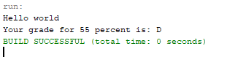

**Q.2]** Consume it using JSP in another project.

**Steps:**

1. Create another project
2. Right click on the Project name -> New -> Web Service Client
3. Paste the link copied above into WSDL URL (above project) as below, and give some package name (import to generate classes?)
4. Create the two jsp files given below
5. Now expand the Web Service References Tab on the left side till the end and drag the web service onto Output.jsp at the red mark below the body tag. You will get the code as shown on the screen. Make the modification in the code as given in the following screen.

**[NOTE:** For some reason this was not working, it was adding different code when dragged. So, rather than doing this, just use the generated classes normally and write the code. First create the service and then the port and call using the port.

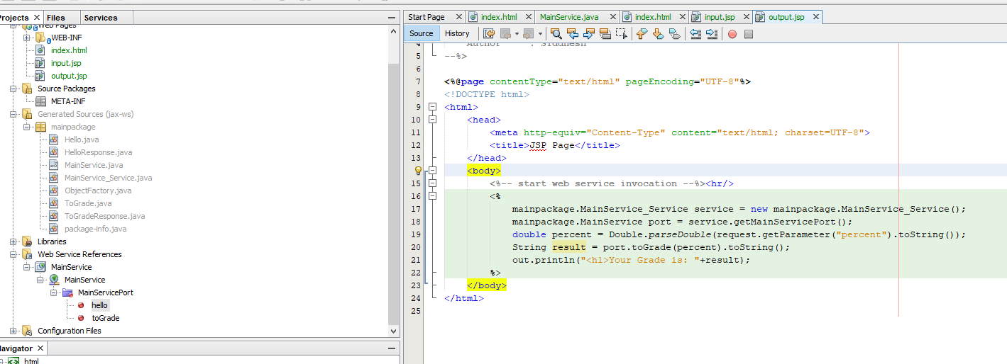

1. Click run on output.jsp

**Codes**

**[input.jsp]:**

<%@page contentType="text/html" pageEncoding="UTF-8"%>

<!DOCTYPE html>

<html>

<head>

<meta http-equiv="Content-Type" content="text/html; charset=UTF-8">

<title>JSP Page</title>

</head>

<body>

<h1>Accept Percentage</h1>

<form action="output.jsp" method="POST">

Enter Percentage - <input type="text" name="percent"/>

<input type="submit"/>

</form>

</body>

</html>

**[output.jsp]:**

<%@page contentType="text/html" pageEncoding="UTF-8"%>

<!DOCTYPE html>

<html>

<head>

<meta http-equiv="Content-Type" content="text/html; charset=UTF-8">

<title>JSP Page</title>

</head>

<body>

<%-- start web service invocation --%><hr/>

<%

mainpackage.MainService_Service service = new mainpackage.MainService_Service();

mainpackage.MainService port = service.getMainServicePort();

double percent = Double.parseDouble(request.getParameter("percent").toString());

String result = port.toGrade(percent).toString();

out.println("<h1>Your Grade is: "+result);

%>

</body>

</html>

**Output:**

